Sparklines
“Sparkline” is a word coined by Edward Tufte to describe “small, high-resolution graphics embedded in a context of words, numbers, images.” Sparklines are “word-sized graphics” which can be used to add context to data in a sentence. More than that, though, sparklines are word like graphics that can be used almost as words.

Tufte gives examples of several types of sparklines, but leaves the definition open in order to accommodate virtually any small, information-rich graphic. His definition is by necessity retroactive and he provides many examples of sparklines from previous work.

In his forthcoming book Beautiful Evidence, Tufte traces the use of word-sized graphics back hundreds of years. He gives the best example as Galileo’s first description of Saturn through his telescope.



The shape of Saturn is thus as shown by perfect vision and instruments but appears thus where perfection is lacking, the shape and distinction of the three stars imperfectly seen.

ET's Sparklines
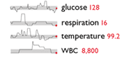
Medical Records. The shaded area indicates the normal range and the red number and dot indicate the latest reading.
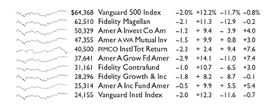
Mutal fund performance. The sparklines give contextual data that shows that most of these funds have virtually identical performance because they track the stock market as a whole.
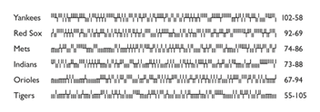
Baseball statistics. An entire season of games for six teams is presented as a whisker win/loss graph to give an at-a-glance summary of each team's relative performance.

Implementation in Ruby
Why’s bumpspark is a limited “toy” sparkline library which can only produce one type of graph. bumpspark uses data: URIs to encode graphics and therefore requires no external libraries. It is only 11 lines of code. But because it uses data: URIs it doesn’t work in Internet Explorer.

Sparklines is a more comprehensive effort by Geoffrey Grosenbach. It is a port of a Python sparklines library. The Sparklines library uses RMagick to output PNGs. Sparklines provides five types of sparklines: a pie chart (which I don’t really see the point of), smooth, discrete, bar, and area.

Using the Sparklines library
Geoffrey’s Sparklines library is easy to install with the gem system.

If you don’t already have the RMagick gem, install it, and then get the sparklines and sparklines_generator gems.

sudo gem install rmagick
sudo gem install sparklines
sudo gem install sparklines_generator

Once the gems are installed, run the sparklines generator to create the sparklines controller and helper files.

ruby script/generate sparklines

Then require sparklines in your environment.rb file:

require 'sparklines'

To the controller you want to use sparklines, add the helper:

class MyController < ApplicationController
helper :sparklines
end

Now you can use the sparkline_tag helper in your view to output sparkline graphics.

Create your own sparklines with monkey patching.
If the Sparklines module doesn’t have the type of graphic you need, you can add it fairly easily with a little bit of RMagick programming and Ruby’s facility for “monkey patching.” It will then be callable from the sparkline_tag helper.

